
LONGTON LANE PRIMARY SCHOOL
‘Believe and Achieve’

BRITISH VALUES AT LONGTON LANE PRIMARY SCHOOL

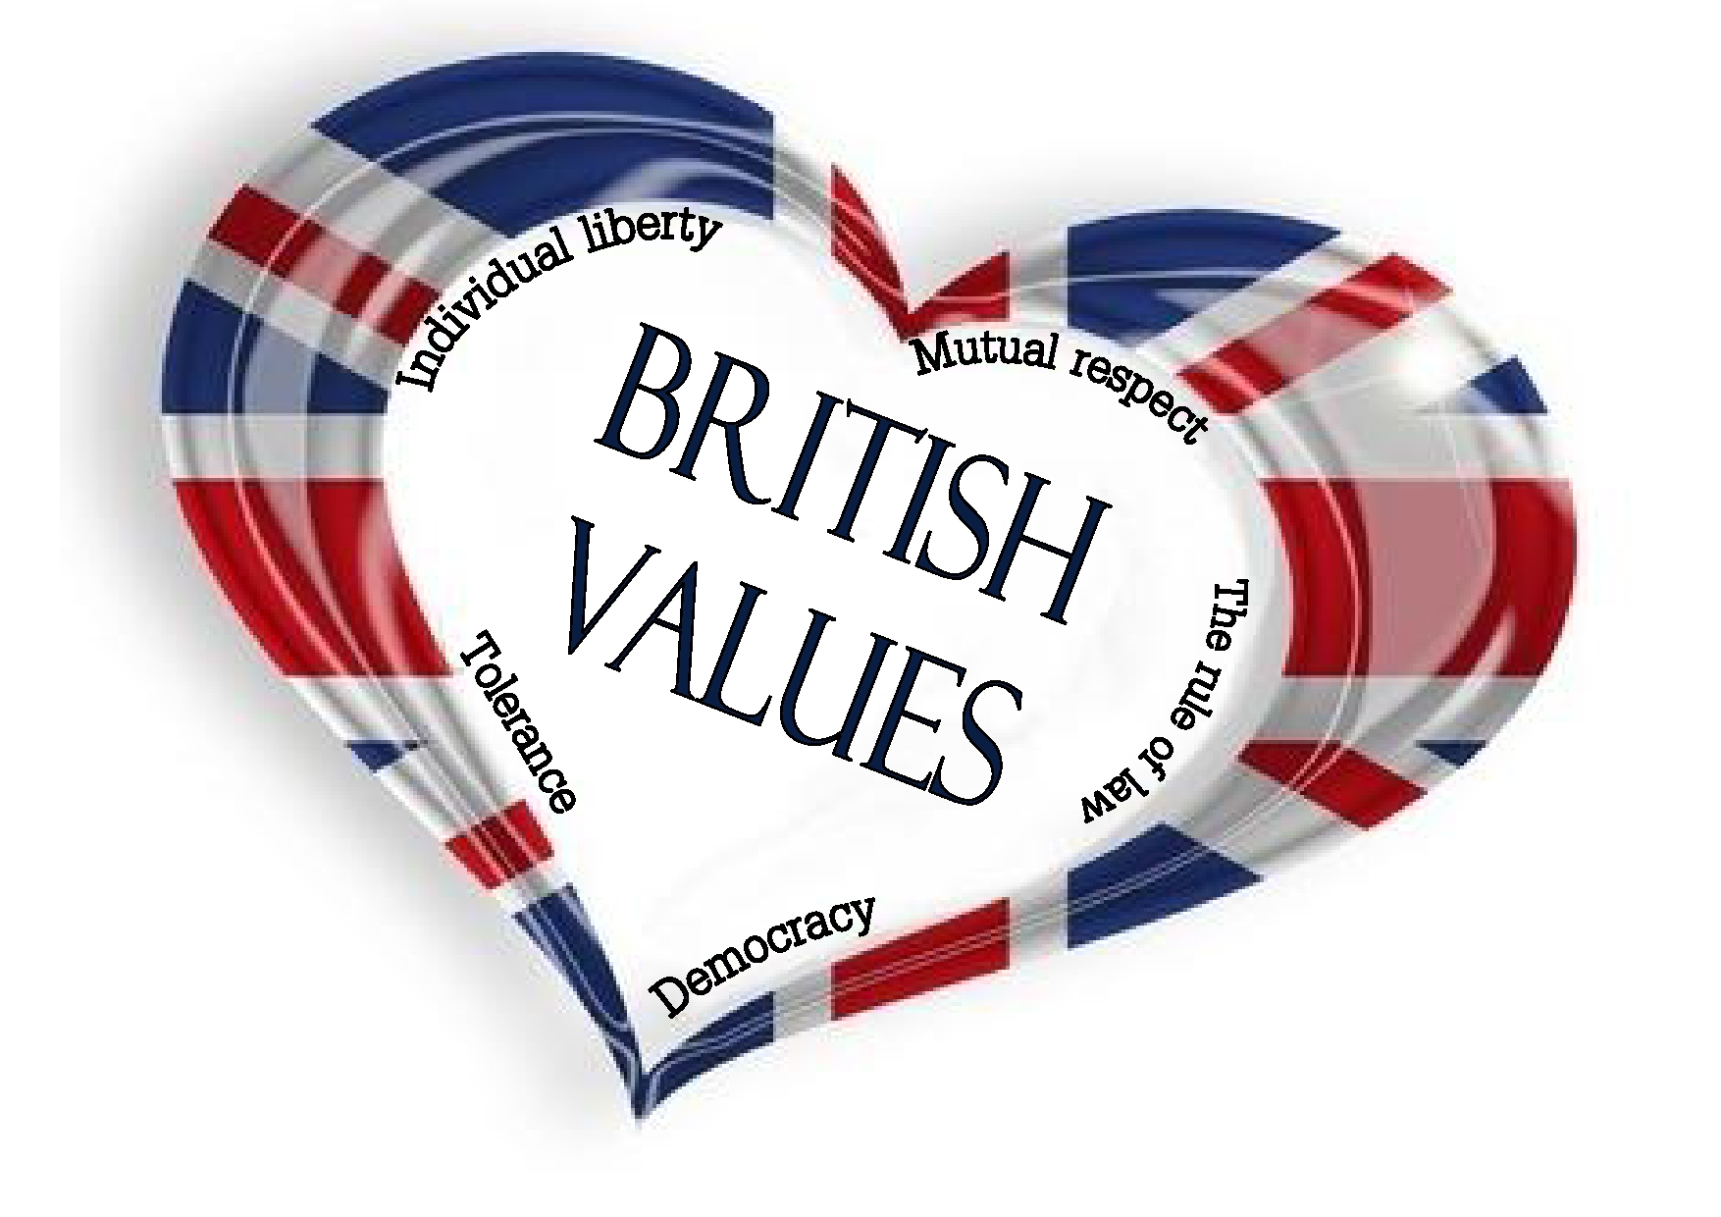

School council, eco council and sports council members are elected

School council, eco council and sports council give every child a voice and an opportunity to change the school in ways they are involved in

Voting opportunities within class i.e choice of storybook, brain breaks needed
Pupils are listened to by adults and taught to listen carefully and with concern to each other

History curriculum – Ancient Greece / Romans

DEMOCRACY

Our curriculum includes current affairs content as relevant

Parent and pupil questionnaires are analysed and used to shape provision in many areas

Class Charters agreed by all

Local councillors to visit school

PSHE – focus on good and bad choices / behaviour choices

Bikeability / Road Safety Week – understand the rules of the road

Assemblies / Collective Worship

Characters in class texts used to discuss what might happen to people who make the wrong choices

Careers events with lawyers and police involved

RULE OF LAW

History – Rule of Law across time

Police visits to school
RE lessons -rule of law i.e crucifixion

Class Charter / Class rules

Do any class texts open up discussion re law?

School council investigate how law is made and understand the process in school

Emotional check-ins each day so children know we have a choice in the way we feel each day

School council, eco council and sports council give every child a voice and an opportunity to change the school in ways they are involved in

Well-Being area in KS2 / Sensory areas in both buildings – choice to self-regulate

Children can participate in a range of extra-curricular activities, the ability to choose their preference

Monitors in class

House Captains and Ambassadors and their role

Computing curriculum and
E-Safety

INDIVIDUAL LIBERTY

Jobs in the UK – explored across the curriculum

Large site where children are trusted to explore expansive boundaries

Staff role modelling respect, equality, diversity and inclusion

PSHE curriculum – stereotypes and challenging them

Freedom of social groups and children of different ages can mix and play

Anti-bullying threaded in curriculum to educate children we are free to be ourselves and no one has the right to make us feel upset about who we are

Behaviour Policy, children have the freedom to explain their choices and input on consequences

School vision statement and aims

Behaviour Policy

School values
Staff code of conduct / Class Charters / Home School agreement / School and class rules

Staff role modelling respect, equality, diversity and inclusion and building strong relationships

MUTUAL RESPECT

PHSE / RSE curriculum / Assemblies / Collective Worship to enhance understanding of mutual respect

Buddy system

In lessons children listen to and respect the contribution of others

Celebrating achievements of others

Speaking and listening skills to respect the views of others to reach decisions

Class texts across school explore mutual respect through characters and behaviours

School vision statement and aims

Behaviour Policy

School values
PSHE / RSE lessons and discussions held

RE- understanding and learning about other faiths / non faiths beyond Christianity

Teaching of many different festivals across the year within the curriculum and assemblies / Collective Worship

TOLERANCE OF THOSE OF DIFFERENT FAITHS AND BELIEFS

History

In lessons children listen to and respect the contribution of others

Trips and visitors into school from different faiths and beliefs

Class readers

Books and displays in school are inclusive of other cultures, beliefs and faiths

