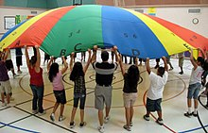

Our Sports Councillors

Year 1- William, Elsie and Dillon

Year 2- Katie, Darcie and Aida-Rae

Year 3-

Year 4- Ava and Flynn

Year 5- Bobby and Lilyjo

Year 6- Jess and Danielle

